INTOSAI Global Survey 2017 - SAIs
1. Welcome to the INTOSAI Global Survey 2017!
This survey is a joint and coordinated INTOSAI effort, administered by the INTOSAI Development
Initiative (IDI). The key partners within INTOSAI in this survey are: the INTOSAI regions, the INTOSAI
Goal Committees, the INTOSAI General Secretariat, the INTOSAI Chair and the Chair of the INTOSAI Strategic Planning Taskforce, in addition to the INTOSAI-Donor Cooperation.
The objectives of the INTOSAI Global Survey are to:
- Collect information and data to guide the capacity development efforts within INTOSAI (includingthose of the IDI, the INTOSAI Regions, and INTOSAI Committees).
- Measure progress in the performance of Supreme Audit Institutions (SAIs) by updatinginformation of the 2010 and 2013 SAI Stocktaking reports.
- Provide data and information for developing and monitoring the implementation of strategicplans within INTOSAI (hereunder the INTOSAI Strategic Plan, IDI Strategic Plan and Regional.
- Strategic Plans as well as the INTOSAI-Donor Cooperation Programme Document.
This survey covers the following thematic areas:
- SAI Independence and Legal Framework
- Developments in SAI Performance
- Capacity Development of SAIs
- Question about sharing data
- Your inputs to the survey
There are a total of 134 questions in this survey. The following questions guided the design of the survey questionnaire.
- What is the overall change in SAI Performance between 2014 and 2017?
- Do SAIs have the degree of independence necessary to fulfil their mandates?
- What is the progress on implementation of ISSAIs since 2014?
- What is the extent and quality of support dedicated for the capacity development of SAIs?
The survey responses will remain confidential, as was the case in 2010 and 2013. This means that no reporting will be done on individual SAIs. Rather, responses will be analysed as an aggregate and shared through the Stocktaking Report as universal or regional data on SAIs. Since this is a coordinated effort, regional bodies and other survey partners would like to have the responses from the SAIs. In section four of this survey questionnaire, your SAI will be asked whether you are willing to share your responses with your regional organisation and other partners and in which topics.

Responding to the Survey
For the 2017 INTOSAI Global Survey, we recommend that SAIs assign a team, instead of a single person, to answer the survey. This can increase the accuracy in the survey answers. In order to cover the information needed to respond to the questions, we suggest that the team be formed by staff members with the following knowledge or functions within the SAI:
- Responsibility for the SAI’s Annual Performance Report, as many of questions in the INTOSAIGlobal Survey are addressed in this annual report.
- SAI’s legal framework, budget, external communication, and audit practices against ISSAIstandards.
- Human resources and staff development in the SAI.
- External partnerships in capacity development programmes.
- A staff to serve as survey secretary and coordinate answers.
We recommend that the survey secretary print copies of the survey questionnaire and call for a meeting with the selected team members to discuss and assign responsibility for answering sections or questions of the survey. Team members then provide answers to the survey secretary in the printed copies. The secretary then enters all the answers into the SurveyMonkey.
The survey application allows for saving your responses as you enter them. Your responses are saved when you click "Next" on each survey page. You will not be able to print a copy of your responses after completing the survey. However, you can go back and review or change your answers.
If necessary, SAIs can seek support for completing this survey from the Secretariat in their regions. The name and contact details for the contact person for the INTOSAI Global Survey in each region follow.
If you have any comment or doubt, do not hesitate in contacting the manager of the INTOSAI Global Survey at IDI.
The contacts are:
Ms. Riselia Bezerra rdb@idi.no or Intosai.gs@gmail.com
+47 9479 8005 or +47 9520 5001

Please submit the completed survey questionnaire by April 30th, 2017 at the latest.
The analysis of the INTOSAI Global Survey will be part of the information basis for the elaboration of the SAI Stocktaking Report 2017, which will be available by September 2017 and shared within the SAI community.
Thank you very much for your time and willingness to take part in the INTOSAI Global Survey.
Best regards,
The INTOSAI Global Survey Partnership
AFROSAI-E
Ms. Annerie Pretorius annerie@afrosai-e.org.za +27 10 286 0104
ARABOSAI
Mr. Hassine Boussandel
Houcine.Bousandel@Courdescomptes.nat.tn
+216 96 030 444
ASOSAI
Ms. Kyung Jin SO koreasai@korea.kr +82-2-2011-2159
CAROSAI
Ms. Siran Mitchell Bent siran.mbent@auditorgeneral.gov.jm +758 468-1501/08/10/13
CREFIAF
Mr. Alain Roger Memvuh Lindouyou malainroger@yahoo.fr +237 678 08 09 94
OLACEFS
Mr. Osvaldo Rudloff Pulgar orudloff@contraloria.cl +56 2 2402 5657
EUROSAI
Ms. Alicia García del Castillo alicia.garcia@tcu.es
+34 91 592 21 12

PASAI
Mr. Tiofilusi Tiueti tiofilusi.tiueti@pasai.org
+64 9 304 1275
INTOSAI Global Survey 2017 - SAIs
2. Contact Information
- 1. Full name of your Supreme Audit Institution

- 2. Please provide the following information for the main contact person(s) for this survey in your SAI: name, position, email and telephone.

INTOSAI Global Survey 2017 - SAIs
3. SAI Independence and Legal Framework
This section has questions about the legal and administrative frameworks for your SAI.
- What is the institutional model of your SAI?
Other institutional model (please specify)
Parliamentary - Single Head model
Parliamentary - Board model
Court - Single Head model
Court – Board model
Part of Ministry of Finance
Other institutional model
- Please select the legal act(s) regulating the SAI’s status and work scope.
Select all that apply.
Constitution
Federal or national law(s)
(Budget) Code(s) Decree(s)
Regulation(s)
Other
- Does the legal act regulating your SAI secure the independence of your SAI?
To a limited extent
To a moderate extent
To the fullest extent Not at all
- Does the legal act regulating your SAI define your SAI's mandate?
To a limited extent
To a moderate extent
To the fullest extent
Not at all
- Does the applicable legislation/regulation in your country specify the conditions of appointments, reappointments, employment and retirement of the Head(s) of SAI, ensuring independence from the Executive.
Note: Head(s) of SAIs are defined as the Auditor General, President of the Court of Account or members of the collegial institution.
Yes
No
- Does the applicable legislation/regulation in your country specify and protect the Head(s) of SAI pertaining to dismissal, security of tenure and legal immunity?
Note: Head(s) of SAIs are defined as the Auditor General, President of the Court of Account or members of the collegial institution.
Yes
No
- To what extent is your SAI free from direction or interference from the Legislature and/or the Executive in the following:
Please check the option that applies to your SAI.
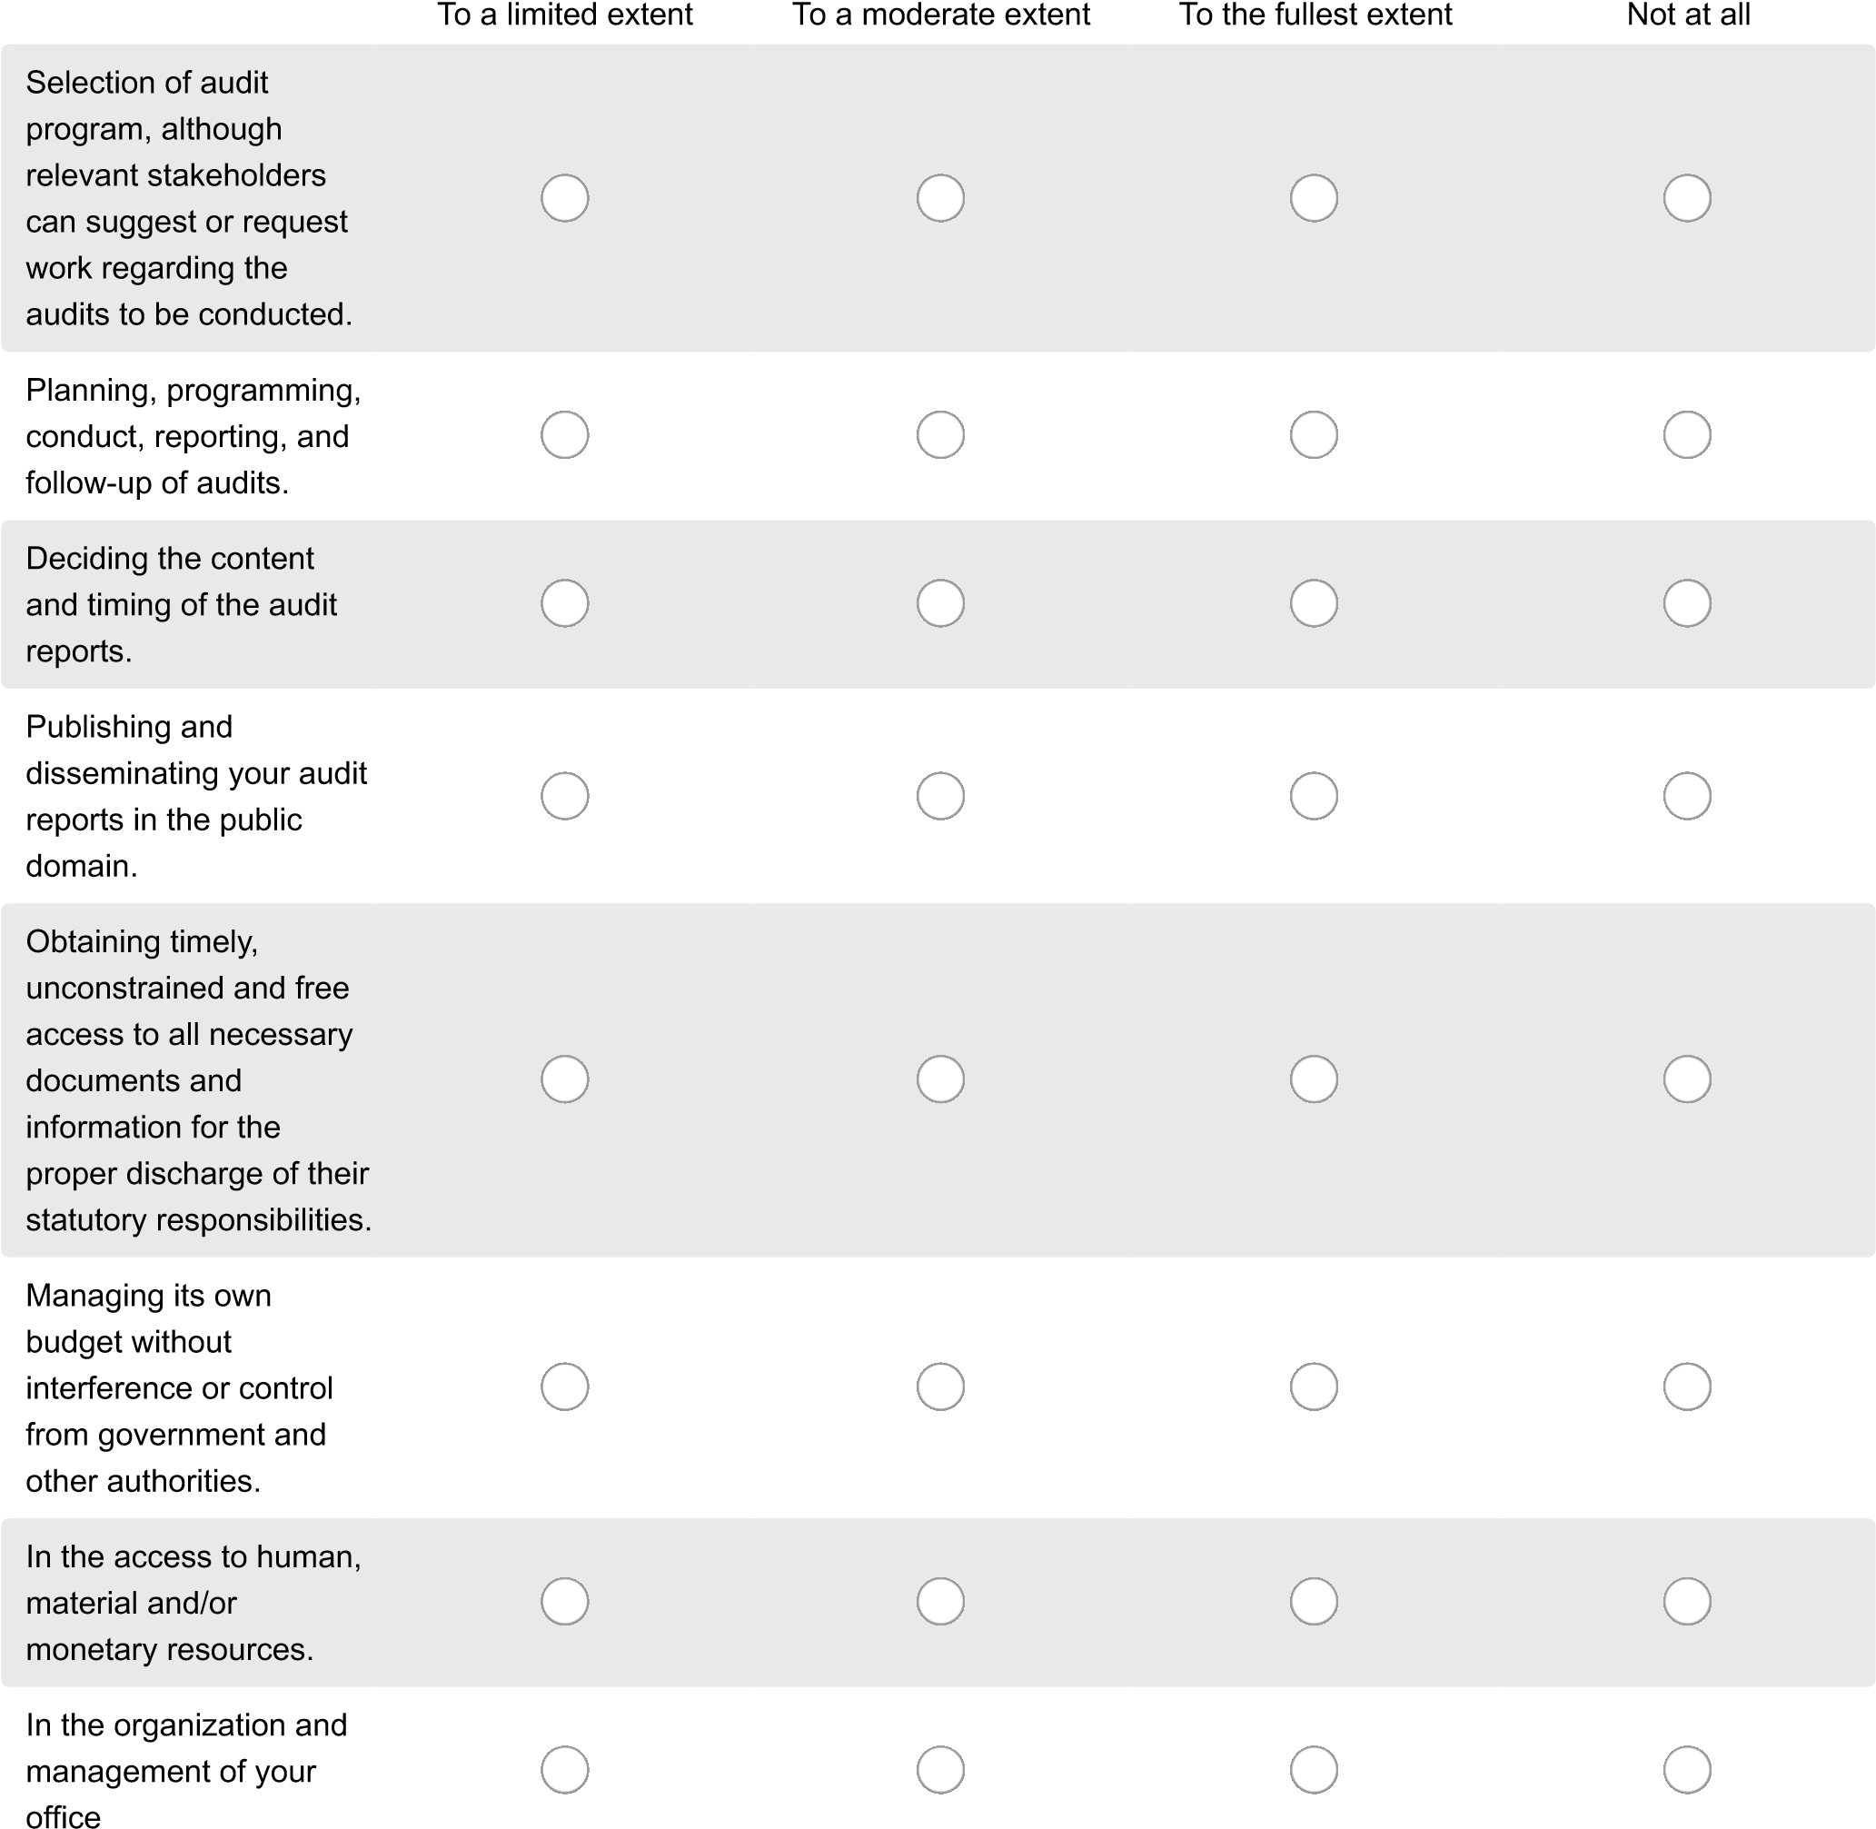
- To what extent have there been cases of interference from the executive regarding your SAI’s budget in the past three years?
To a limited extent
To a moderate extent
To the fullest extent
Not at all
- Is the Legislature (or one of the Parliament/Congress commissions) responsible for ensuring that your SAI have the proper resources to fulfil its mandate?
Yes
No
- Does your SAI have opportunity to appeal to the Legislature/Parliament/Congress if the resources provided are insufficient to fulfil its mandate?
Yes
No
- Does the Legislature/Parliament/Congress count on a panel of parliamentarians or congressional representatives to oversee your SAI’s annual funding request?
Yes
No
- Does your SAI have the legal mandate to carry out audit on:

Yes
No
Federal or National level
Regional level
Local or municipal level
Autonomous & semi-autonomous bodies
State owned enterprises/parastatals
Non-government organizations
Government-funded organizations
Public-private enterprises
- Does your SAI have the mandate to cover the following audits:

Yes
No
Funds used on contracts
and public works
Electronic data
processing facilities
Audit of the use of
subsidies granted from
public funds
License agreements or
concessions
Security/defence funds
Access to bank
information
Audit of public
authorities and other
institutions abroad
Audit of international
and supranational
organizations
Audit the collection of
taxes and examination
of the system and
efficiency of tax
collection and the
achievement of revenue
targets
Other audits
- Please select the audit stream(s) that your SAI is mandated to conduct.
Select all that apply.
Financial Audits
Compliance Audits
Performance Audits Specialized audits
- Does your SAI have a mandate to:

Yes
No
Share information with
specialized anti-
corruption institutions.
Investigate corruption
and fraud issues.
Sanction corruption-
related cases.
Carry out jurisdictional
control and to judge
accounts issued to
public institutions and
companies.
Sanction officials
responsible for
mismanagement of
public funds.
Exercise oversight of
national institutions
whose mandate is to
investigate corruption
and fraud issues.
INTOSAI Global Survey 2017 - SAIs
4. About your SAI
The questions in this section cover your SAI’s profile, internal governance, operations, audit practices, reporting, professionalization and stakeholder management.

Budget of SAI, mandated and audited entities
- Did your SAI budget increased in real terms (accounting for inflation) in the in the past three (3) years?
Yes No
- What was your SAI’s annual budget in the past 3 years (in your country’s nomination)?
Note: Please also provide your SAI’s average annual budget in the past 3 years. For calculating the average: (Add the annual budgets for the past 3 years) then divided by 3.
2016
2015
2014
Average of the three years
- What was your SAI’s annual budget in the past 3 years (in US dollar)?
Note 1: For conversion from your monetary currency to US dollar, please use the exchange rate of 30 January 2017.
Note 2: Please also provide the average of the past three years. For calculating the average: (Add the annual budgets for the past 3 years) then divided by 3.
2016
2015
2014
Average of the three years
- What was the total budget of mandated entities, in the past 3 years (in your country’s currency)?
Note 1: For this question, only entities for which your SAI has financial and compliance audit responsibility should be included. Note 2: Budget figures on mandated entities may not be readily available to many SAIs due to complex country structures or the way budget systems are set up. We would ask you to provide the information that you are able to obtain.
Note 3: Calculating the average: (Add the annual budgets for mandated entities for the past 3 years) then divided by 3.
2016
2015
2014
Average of the three
years.
- What was the total budget of mandated entities, in the past 3 years (in USD)?
Note 1: Please provide the information in US dollar. For conversion from your own monetary currency to US dollar, please use the exchange rate of 30 January 2017.
Note 2: For this question, only entities for which your SAI has financial and compliance audit responsibility should be included. Note 3: Budget figures on mandated entities may not be readily available to many SAIs due to complex country structures or the way budget systems are set up. We would ask you to provide the information that you are able to obtain.
Note 4: Calculating the average: (Add the annual budgets for mandated entities for the past 3 years) then divided by 3.
2016
2015
2014
Average of the three years
- What was the total budget of audited entities, in the past 3 years (in your country's currency)?
Note 1: This question refers to the entities your SAI audited during the specified period.
Note 2: Calculating the average: (Add the annual budgets for mandated entities for the past 3 years) then divided by 3.
2016
2015
2014
Average of the three years
- What was the total budget of audited entities, in the past 3 years (in USD)?
Note 1: This question refers to the entities your SAI audited during the specified period.
Note 2: Please provide the information in US dollar. For conversion from your own monetary currency to US dollar, please use the exchange rate of 30 January 2017.
Note 3: Calculating the average: (Add the annual budgets for mandated entities for the past 3 years) then divided by 3.
2016
2015
2014
Average of the three years
- Did your budget for professional development increased in real terms (adjusted for inflation) in the past three years?
Yes
No
Do not know
- What is the total annual budget for professional development, in the past 3 years (in your country's currency)?
Note 1: Professional development includes internal training, costs of external training paid by your SAI, fees for external certification, scholar fees master or specialized program, e-learning program, fee for maintaining certification and other similar initiatives.
Note 2: Calculating the average: (Add the annual budgets for mandated entities for the past 3 years) then divided by 3.
2016
2015
2014
Average of the three years
- What is the total annual budget for professional development, in the past 3 years (in USD)?
Note 1: Professional development includes internal training, costs of external training paid by your SAI, fees for external certification, scholar fees master or specialized program, e-learning program, fee for maintaining certification and other similar initiatives.
Note 2: For conversion from your own monetary currency to US dollar, please use the exchange rate of 30 January 2017.
Note 3: Calculating the average: (Add the annual budgets for mandated entities for the past 3 years) then divided by 3.
2016
2015
2014
Average of the three years
INTOSAI Global Survey 2017 - SAIs
5. About your SAI

Internal Governance & Ethics
- Does your SAI have a Code of Ethics?
Yes
No
INTOSAI Global Survey 2017 - SAIs
6. About your SAI
- Is your SAI’s Code of Ethics made available to the public?
(e.g. posted in the SAI website, printed copies available within the SAI premises and available on public demand, etc.)
Yes
No
- Please select which apply to your SAI

To a limited extent
To a moderate extent
To the fullest extent
Not at all
Does your SAI ensure
that staff are acquainted
with the Code of Ethics?
Does your SAI monitor
the application of the
Code of Ethics?
Are there measures in
place in your SAI to deal
with non-compliance
with the Code of Ethics
and the SAI implements
them?
- Does your SAI have an internal audit function?
Yes
No
INTOSAI Global Survey 2017 - SAIs
7. About your SAI
- Does the Internal Audit unit/department have sufficient resources to carry out its tasks?
Note: By “sufficient resources”, we mean number of staff and budget.
Yes
No
- Are your SAI’s financial statements subject to external audit?

Yes No Audit Process
- Which audit approach(es) does your SAI use for selecting audits for the annual program?
Please select the option(s) that apply to your SAI.
Risk based audit
System based audit
Other(s)
- If auditors in your SAI use electronic tools (software) for conducting and documenting audits, they do for which audit stream?
Please select the option(s) that apply to your SAI.
Financial Audit stream
Compliance Audit stream
Performance Audit stream
No electronic tools used
- Which of the following audits do your SAI do?
Please select all that apply to your SAI.
Financial Audit
Compliance Audit
Performance Audit
Jurisdictional control
Others
- For Financial audit, did your SAI meet the following audit coverage criteria in the past audit year: at least 75% of financial statements received are audited (including the consolidated fund / public accounts or where there is no consolidated fund, the three largest ministries)?
Yes
No
- If no, how much percent of the statements received were audited?
Note: Please enter the numeric value of the percentage only (e.g 50, not 50%).

- For Compliance audit, did your SAI meet the following audit coverage criteria: the SAI has a documented risk basis for selecting compliance audits that ensures all entities face the possibility of being subject to a compliance audit, and at least 60% (by value) of the audited entities within the SAI’s mandate were subject to a compliance audit in the last audit year?
Yes
No
- If no, what was the percentage of the audited entities within the SAI’s mandate that were subject to a compliance audit in the last audit year?
Note: Please enter the numeric value of the percentage only (e.g 50, not 50%).

- For Performance audit, did your SAI meet the following audit coverage criteria: on average in the past three years, the SAI has issued at least ten performance audits and/or 20% of the SAI’s audit resources have been used for performance auditing?
Yes
No
- If no, how many performance audits did the SAI issued in the past three years?
Note: Please enter the numeric value only (e.g 5, and not 5 audits).

Timely submission and publishing audit reports and judgement
- When was the latest consolidated annual audit report from your SAI issued to Parliament/Congress (or other recipients as determined by law)?
Note: Usually legal time limit is specified in the legal framework of the SAI or determined by the SAI.
Within the stipulated legal time limit
Within six months after stipulated legal time limit
Within one year after stipulated legal time limit
More than one year after stipulated legal time limit
For our SAI, there is no time stipulation for issuing the consolidated annual audit report
- How many audit reports were produced in the last completed audit year?
Note 1: The audit ‘reports’ refer to all the financial, compliance, performance and other audit reports that the SAI produced the past audit year.
Note 2: Please enter the numeric value only (e.g 5, and not 5 audits).
- How many audit reports were made public in the last completed audit year?
(e.g. through press conference, posting in the SAI website)

- The following questions are for SAIs organized as judicial or court systems only.
How many
judgements/sanctions were completed in the last audit year?
How many
judgements/sanctions
were made available to the
public?
How many accounts were
received in the last audit
year?
How many accounts were
judged in the last audit
year?
INTOSAI Global Survey 2017 - SAIs
8. About your SAI

Quality Control and Assurance
“Quality Controls” encompasses the policies and procedures that are put in place in an SAI to assure that its audit work is of a consistently high quality. It is carried out as an integrated part of the audit process.
“Quality Assurance” is the process established by a SAI to ensure that: (a) Needed controls are in place; (b) Controls are being properly implemented; and, (c) Potential ways of strengthening or otherwise improving controls are identified. Quality assurance can either be done on audits that have been completed or while in progress at various phases of the audit.
- Which audit streams do the quality control in your SAI cover?
Please select all that applies to your SAI.
Financial audit
Compliance audit
Performance audit
Our SAI does not have a quality control system
- For SAIs organized as judicial or court systems, does the quality control mechanism also cover jurisdictional function and judgement?
Please select the answer that applies to your SAI.
Yes
No
Our SAI does not have a quality control system
- Which audit streams does quality assurance cover in your SAI?
Please select all that applies to your SAI.
Financial audit
Compliance audit
Performance audit
Our SAI does not have quality assurance mechanisms
- For SAIs organized as judicial or court systems, does the quality assurance mechanism also cover jurisdictional function and judgement?
Please select the answer that applies to your SAI.
Yes
No
Our SAI does not have a quality assurance system

- Which mechanism does your SAI use for quality assurance?
Internal quality assurance: periodic review performed by persons within the SAI, with knowledge of the audit procedures, practices and standards.
External quality assurance: an independent organization external to the SAI (e.g. peer SAI, private audit firm, management consulting firm, academic expert or regulatory body) performs a quality assurance review to appraise the quality of the audit activity and provide
independent assurance of the audit quality. The reviews are conducted periodically.
Internal quality assurance, by an independent quality assurance unit, department or group.
Internal quality assurance, through a mechanism involving different divisions, units and/or sections.
External quality assurance.
No quality assurance mechanism used currently.
- If your SAI has a quality assurance mechanism, what is the system your SAI uses for following up on the conclusions and recommendations of the quality assurance mechanism?
Please write the name of the system or a very short description.

Following-up on SAI recommendations
- Does your SAI issue audit opinions for the following audit streams?
For financial audits.
For compliance audits.
For performance audits.
- Does your SAI provide recommendations for the following audit streams?
For financial audits.
For compliance audits.
For performance audits.
- Does your SAI have an internal system to follow-up on the observations and recommendations made to the audited entities, including the actions taken by the auditees’ relevant authorities?
Yes No

About your SAI
- Does your SAI have an incentive or penalty system for implementation and non-implementation of audit recommendations?
Yes, and the incentives or penalties are consistently applied
Yes, and the incentives or penalties are applied to a moderate extent Yes, but the incentives or penalties are rarely applied
No
- Which of the following stakeholders are involved in your follow-up system?
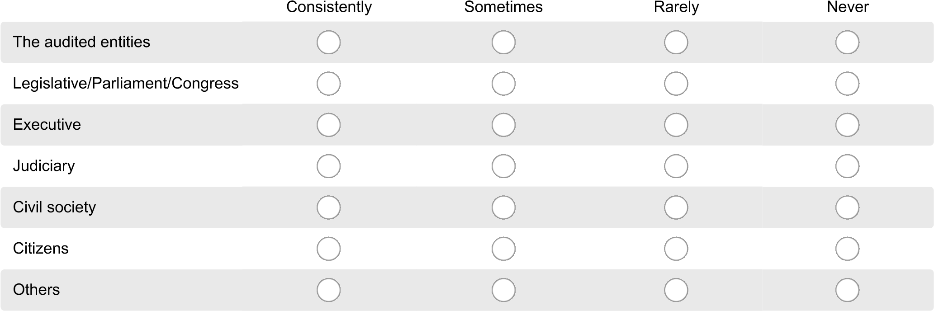
- To what extent were recommendations implemented in the last three audit years?

To a limited extent
To a moderate extent
To the fullest extent
No at all
For financial audits
For compliance audits
For performance audits
For specialized audits
(
e.g. Public debt,
environment)
- For SAI with court system or with a mandate to issue sanctions, do you follow-up on SAI sanctions?
Yes No

About your SAI
60. To what extent were sanctions implemented in the last three completed audit year?
To a limited extent
To a moderate extent
To the fullest extent
Not at all

Other Core Services
- Does your SAI provide advisory services to the Congress/Parliament?
To a limited extent
To a moderate extent
To the fullest extent
Not at all
- Does your SAI provide advisory services to other public entities?
To a limited extent
To a moderate extent
To the fullest extent
Not at all
- Does your SAI carry out other non-audit related responsibilities?
If yes, please specify which non-audit related responsibilities your SAI carries out
To a limited extent
To a moderate extent
To the fullest extent
Not at all

About your SAI

Strategic Plan
- Does your SAI have a strategic plan?
Yes
No
INTOSAI Global Survey 2017 - SAIs
12. About your SAI
- Was the strategic plan based on a holistic needs assessment of the SAI?
Yes
No
- Does your SAI have an operational or annual plan for the current audit year in order to implement the strategic plan?
Yes
No
We have annual plans, but they are not based on the strategic plan
- Are your strategic and operational plans made available to the public, through your website for example?
Yes, both strategic and operational plans
Yes, but only the strategic plan
Yes, but only the operational plans
No
- What mechanisms does your SAI have in place in this audit year for monitoring and evaluating the strategic and operational plans?
Select as many options as applicable.
Systematic monitoring of the implementation of activities
Systematic monitoring of the implementation of outputs
Systematic monitoring of the implementation of the plans through performance indicators’
Internal evaluation(s)
External evaluation(s)
No systematic monitoring of the implementation of Strategic and Operational Plans
No evaluation(s)
INTOSAI Global Survey 2017 - SAIs
13. About your SAI

ISSAI Standards
- Has your SAI developed or adopted audit standards based on or consistent with which ISSAI level?
Please check the options that apply to your SAI.
Standards adopted, but

Consistent with the
level
ISSAIs
3
Consistent with the
level
ISSAIs
4
not yet consistent with
ISSAIs
Did not adopt standards
Financial audit
Compliance audit
Performance audit
- Does your SAI have Audit Manuals in the following audit streams:
Please check the options that apply to your SAI.
Standards adopted, but

Yes,consistent with the
level 3 ISSAIs
Yes,consistent with the
level 4 ISSAIs
not yet consistent with
ISSAIs
Did not adopt ISSAI
standards
Financial audit
Compliance audit
Performance audit
INTOSAI Global Survey 2017 - SAIs
14. About your SAI

Human Resources
Please provide the following information about SAI staff.
Note 1: Information about number of staff should be answered as of to date (current numbers of staff), disaggregated by gender. Note 2: To make sure we have a comparable number across SAIs, we ask for ‘full-time equivalent’ (FTE), which is a unit equivalent to one employee working full-time. For example, if you have two employees working 50%, the two employees equal 1 FTE. 71. Total number of staff in your SAI
Male
Female
- Total number of Head(s) of SAI
Note 1: Heads of SAIs are defined as the Auditor General, President of the Court of Account or members of the collegial institution.
Note 2: Please write the number zero (0) to indicate an absence of male or female.
Male
Female
- Total number of members of senior management.
Note 1: Members of the senior management are Deputy AGs, Department Directors, Prosecutor, Presidents of Chamber and Secretary
Generals.
Note 2: Please write the number zero (0) to indicate an absence of male or female.
Male
Female
- Total number of professional audit staff (non-senior management).
Note: Please write the number zero (0) to indicate an absence of male or female.
Male
Female
- Total number of support staff (audit).
Note: Please write the number zero (0) to indicate an absence of male or female.
Male
Female
- Total number of support staff (corporate service).
Note: Please write the number zero (0) to indicate an absence of male or female.
Male
Female
- Does your SAI have its own recruiting and deployment mechanism?
To a limited extent
To a moderate extent
To the fullest extent
Not at all
- Does your SAI have written job descriptions for positions?
To a limited extent
To a moderate extent
To the fullest extent Not at all
- Are members of SAI senior management normally recruited internally?
Note: Members of the senior management are Deputy AGs, Department Directors, Prosecutor, Presidents of Chamber and Secretary Generals.
To a limited extent
To a moderate extent
To the fullest extent Not at all
- Does your SAI apply a "minimum qualification framework" for the following appointments?
Note: "minimum qualification framework" is a formal system describing the minimal qualifications for positions.
Yes No
Audit staff
Corporate/non-audit
staff (e.g. HR)
- What is the extent of staff turn-over in your SAI in the past three years?
Between 0 and 20% a year
Between 20% and 40% a year
Between 40% and 60% a year Between 60% and 80% a year
Over 80%
Do not know
INTOSAI Global Survey 2017 - SAIs
15. About your SAI

Gender policy
- Does your SAI have a gender policy?
Note: A policy developed by the SAI or adopted government's global policy or from the region.
Yes
No
- Which mechanisms are in use to monitor the implementation of the gender policy?
Our SAI monitor gender indicators in the Strategic or Annual plans.
Our SAI monitor the gender-related activities stated in the Strategic or Annual plans.
Our SAI carry out internal evaluation(s) of gender policy.
Our SAI carry out external evaluation(s) of gender policy.
We do not monitor or evaluate the gender policy.
- Does your SAI have a manual on auditing gender issues?
Yes
No
- Did your SAI do dedicated audit on gender in the past three years?
Note: Audits specifically designed to assess the implementation of gender policies, strategies, programmes and corresponding budgets. For example, assessment of the degree of government compliance with national and/or international commitments to gender
equality.
To a limited extent
To a moderate extent
To the fullest extent Not at all
- Did your SAI include gender assessments in audit work in the past three years?
Note: For example, assessment of the degree of government compliance with the implementation of national gender legislation, policy
and/or action plan in the course of auditing institutions and funds.
To a limited extent
To a moderate extent
To the fullest extent
Not at all
INTOSAI Global Survey 2017 - SAIs
16. About your SAI

SAI performance assessment
- Have your SAI carried out an assessment of its performance in recent years?
Please select the option(s) that applies.
No
Yes, in 2017
Yes, in 2016
Yes, in 2015
Yes, in 2014
INTOSAI Global Survey 2017 - SAIs
17. About your SAI
- Which tool(s) was used for the performance assessment(s)?
Other (please specify)
SAI Performance Measurement Framework (SAI PMF)
Peer Review Guide and Checklist
Blend Peer Review and SAI PMF
Institutional Capacity Building Framework (ICBF, AFROSAI-E)
Assessment tool developed by the SAI
Other
- What approach was used for the performance assessment?
Please select applicable option(s).
Self-assessment
Peer assessment (conducted by another SAI)
External assessment (e.g. conducted by external consultants or organisation)
A mix of internal and external assessment
Other
- Which type of sample was used for the SAI’s performance assessment(s)?
Please select applicable option(s).
Simple Random Sampling (a sample of n audit files is chosen randomly)
Simple Purposive Sampling (a sample of n audit files is selected based on one or more criterion)
Stratified Random Sampling (a sample of n audits from each audit stream is selected randomly in order to obtain a sample that is representative of the SAI’s entire audit work)
Multi-Stage Sampling (constructed by taking a series of simple random samples in stages).
Other sampling method
- Which audit streams did the SAI performance assessment cover?
Select applicable option(s).
Financial audit
Compliance audit
Performance audit
Jurisdictional control (for the court SAIs)
- Was the performance assessment externally quality assured?
Yes
No
- Did your SAI report on the performance assessment externally to stakeholders (e.g. legislative, publicly, etc)?
Yes
No
- What was the results of the performance assessment for your SAI?
Select applicable option(s).
Change/amend of any aspect of the legal framework affecting the SAI (e.g. in the audit law)
Increase/decrease in SAI budget by the legislative (or another body responsible for the SAI’s budget) Review of strategic plan
Review (adjustments) the technical assistance programme the SAI had with one or more cooperation partners.
Orient technical assistance initiatives with peer SAIs.
Access to funding from international cooperation partners for capacity development initiatives reflecting key areas identified in the assessment.
Provided guidance for the SAIs’ internal training programme
Review SAI’s audit manuals
Increased resources for both the quality control and quality assurance systems
Improved or update the audit methodology in order to comply with the relevant standards.
Improved or updated the SAI procedure for judgement and sanction. (Only for SAI with jurisdictional function).
Developed and implemented, or improved, a stakeholders engagement strategy or plan.
Set up and implement, or improving, a system for following up audit recommendations and/or sanctions. None
Other(s)
- If you have used the SAI Performance Measurement Framework (SAI PMF), could you please share your opinion about the tool?
Note: The SAI PMF is an assessment tool developed specifically for the use of SAIs. Your inputs are valuable for the tool’s
development.
In writing, please be as direct and brief as possible.
Three main strengths of
the tool
Three main weaknesses
of the tool
- If you have not yet used the SAI Performance Measurement Framework (SAI PMF), could you please share: The main reasons why your SAI did not use the SAI PMF to carried out its performance assessment.
In writing, please be as direct and brief as possible.

- Does you your SAI plan on doing a SAI Performance Measurement Framework (SAI PMF) in the future?
Yes
No
INTOSAI Global Survey 2017 - SAIs
18. About your SAI

Communication and Stakeholder Management
- Does your SAI have a communication policy?
Yes No
- Please select the mass media your SAI uses to report/disseminate its audit work.

To a limited extent
To a moderate extent
To the fullest
Not at all
Television
Radio
Press
Internet (e.g. SAI’s
webpage and/or social
networks, etc)
Gazettes or magazines
No mass media used
frequently by SAI
- If your SAI promote the participation of citizens in supreme auditing-related tasks, what is the scope of their involvement?
Citizens’ involvement in the planning of the annual audit plan (e.g. through following-up on citizens’ complaints, denunciations and suggestions)
Citizens’ ´participation in the conduction of audits.
Citizens’ collaboration in the dissemination of the audit findings.
Citizens’ monitoring of the auditee’s actions with regard to the SAI’s audit findings and recommendations.
Other(s)
- Does your SAI take into account Parliament’s/Congress’ audit requests to define its annual audit plan?
To a limited extent
To a moderate extent
To the fullest extent
Not at all
- Does your SAI take into account the government’s requests or comments when the SAI plans its objectives?
To a limited extent
To a moderate extent
To the fullest extent Not at all
- Does your SAI involve civil society when following up on audit recommendations?
For example, through partnerships with research institutes or universities or trade unions.
To a limited extent
To a moderate extent
To the fullest extent
Not at all
INTOSAI Global Survey 2017 - SAIs
19. Capacity Development
This section asks questions about internal and external capacity development initiatives of SAIs and in partnerships with INTOSAI bodies.

Training
- Is your SAI an "accredited training institution" (a recognised external training or professional body has accredited the SAI as a professional training institute)?
Yes
No
- Does your SAI develop and implement a training plan?
Yes
No
- Does your SAI have leadership training available to management staff?
Yes
No
- Who administers training in your SAI?
Training unit, department or institute
Human resources
Administered by each department head/manager
Other
There is no focal point for training in our SAI
- What are the three (3) most utilized approach for training in your SAI?
Please select up to three approaches.
Internal training courses
External training courses
On-the-job training
Job rotation
Mentoring
Support to attend certification programmes (e.g. public auditing)
Other(s)
No training takes place in our SAI
- What are the two (2) most utilized approach in your SAI for staff to transfer knowledge and skills from participation in external capacity development programmes?
You may select only one or two approaches.
Trained staff run formal training courses to peers
Trained staff are used to develop or update audit methodology tools and/or manuals
Trained staff run presentation to peers about the training experiences
Trained staff run presentation to management about the training experiences
On the job training within the trained staffs’ unit/department
Other(s)
None
INTOSAI Global Survey 2017 - SAIs
20. Capacity Development

Peer to Peer Support
- Did your SAI provide capacity development support to one or more peer SAIs in the past three year?
Select option(s)
No
Yes, in 2014
Yes, in 2015
Yes, in 2016
- Which areas did the support cover?
Select option(s)
Peer Review
Audit area
Human Resources Management
Others
- To SAIs in which region(s) did your organisation provide support?
Select option(s)
AFROSAI
AFROSAI-E
ARABOSAI
ASOSAI
CAROSAI
CREFIAF
EUROSAI
OLACEFS
PASAI
- Did your SAI participate in joint or coordinated audits since 2014?
Yes
No
INTOSAI Global Survey 2017 - SAIs
21. Capacity Development
- If yes, in which context?
Please select all that apply.
Facilitated by your or another SAI
Facilitated by the IDI
Facilitated by your regional organisation
Facilitated by another regional organisation (other than yours)
Facilitated by the Capacity Building Committee
Facilitated by international cooperation partner(s)
- In how many joint or coordinated audits did you participate?

- What were the topic(s) of the joint or coordinated audit(s) your SAI participate in?
Please list the topics

INTOSAI Global Survey 2017 - SAIs
22. Capacity Development

Support from the IDI, CBC and KSC
- Which IDI programmes has your SAI participated in since 2014 that address priority areas identified in your SAI’s strategic plan?
Please only list those programmes that are identified as priority areas in your strategic plan or annual plan documents.

- How many professional staff in your SAI participated in IDI programmes since 2014?
If your SAI does not know, please write: Do not know.

- Of the staff in your SAI that participated in IDI programmes in the past three (3) years, how many still working in your SAI?
If your SAI does not know, please write: Do not know.

- Which IDI global public goods have your organisation use since 2014?
By “use” we mean that the SAI uses or used the handbook or guide not only while staff participated in a given IDI programme, but beyond the programme.
Others (please specify)
None
ISSAI Implementation Handbooks
Needs Assessment Handbook
Strategic Planning Handbook
Quality Assurance in Financial Audit Handbook
Quality Assurance in Performance Audit Handbook
IT Audit Handbook
Programme Management Handbook
Auditing Fraud and Corruption, Guide
Risk- Based Approach to Financial Auditing, Guide
Learning for Impact, Guide
Auditing Public Debt Management, Guide
Human Resources Management, Guide
SAI Performance Measurement Framework (SAI PMF)
Others
- Did your SAI use any members of the “specialist pools” trained by the IDI, since 2014?
“Specialist pools” includes Training specialists, PDA champions, IT champions, MDP champions, and ISSAI facilitators.
By “used” is meant that a member of the specialist pools carried out one or more activities in your SAI in the area she or he was trained to be an specialist. (E.g. an ISSAI facilitator was asked and revised audit methodology or developed the curriculum and training materials for the training institute or unit).
If yes, how many members of the “specialist pools” did your SAI use? IIf your SAI does not know, please write: Do not know.)
Yes
No
Do not know
- What guide(s) developed by the Capacity Building Committee (CBC) did your SAI use in the last 3 years?
The question refers to the use of guides beyond activities organised by the CBC.
Others (please specify)
None
SAI Capacity Building Guide
Managing Information and Communication, Guide
Guide for Cooperative Audit Programs between SAIs
Guidelines for Internship Programs
Human Resources Management for SAIs
Peer Review Guide and Checklist
Disaster Risk Reduction, Guide
Use and Impact of Audit Reports, Guide
Others
- What guides developed by the Knowledge Sharing Committee (KSC) did your SAI use in the last 3 years?
The question refers to the use of guides beyond activities organised by the KSC, CBC or any other committee.
None
ISSAI 5010 - Audit of International Institutions - Guidance for Supreme Audit Institutions (SAIs)
ISSAI 5110 - Guidance on Conducting Audits of Activities with an Environmental Perspective
ISSAI 5120 - Environmental Audit and Regularity Auditing
ISSAI 5130 - Sustainable Development: The Role of Supreme Audit Institutions
ISSAI 5140 - How SAIs may co-operate on the audit of international environmental accords
ISSAI 5210 - Guidelines on Best Practice for the Audit of Privatisations
ISSAI 5220 - Guidelines on Best Practice for the Audit of Public/Private Finance and Concessions
ISSAI 5230 - Guidelines on Best Practice for the Audit of Economic Regulation
ISSAI 5240 - Guidelines on Best Practice for the Audit of Risk in Public/Private Partnerships (PPP)
ISSAI 5300 - Guidelines on IT Audit
ISSAI 5310 - Information System Security Review Methodology - A Guide for Reviewing Information System Security in
Government Organisations
Others (please specify)
ISSAI 5410 - Guidance for Planning and Conducting an Audit of Internal Controls of Public Debt
ISSAI 5411 - Debt Indicators
ISSAI 5420 - Public Debt: Management and Fiscal Vulnerability: Potential Roles for SAIs
ISSAI 5421 - Guidance on Definition and Disclosure of Public Debt
ISSAI 5422 - An Exercise of Reference Terms to Carry Out Performance Audit of Public Debt
ISSAI 5430 - Fiscal Exposures: Implications for Debt Management and the Role for SAIs
ISSAI 5440 - Guidance for Conducting a Public Debt Audit - The Use of Substantive Tests in Financial Audits
ISSAI 5450 - Guidance on Auditing Public Debt Information
ISSAI 5500 - Introduction to Guidance for Audit Work on Disaster-related Aid
ISSAI 5510 - Audit of Disaster Preparedness
ISSAI 5520 - Audit of Disaster-related Aid
ISSAI 5530 - Adapting Audit Procedures to Take Account of the Increased Risk of Fraud and Corruption in the Emergency Phase
following a Disaster
ISSAI 5540 - Use of Geospatial Information in Auditing Disaster Management and Disaster-related Aid
ISSAI 5600 - Peer Review Guidelines
ISSAI 5700 - Guideline for the Audit of Corruption Prevention
ISSAI 5800 - Guide on Cooperative Audit between Supreme Audit Institutions
Others
124. Does your SAI use or used technical guides developed by an INTOSAI regional organisation?
Yes
No
INTOSAI Global Survey 2017 - SAIs
23. Capacity Development

Assessment of capacity development support
- Which two main factors contributed to the success/failure of the capacity development support provided by your regional body?
In writing, please be as direct and brief as possible.
Two factors that contributed to the success
of the intervention(s), if
successful
Two factors that limited the
effectiveness of the
intervention(s), if any
- Which two main factors contributed to the success/failure of the capacity development support provided by the IDI?
In writing, please be as direct and brief as possible.
Two factors that contributed to the success
of the intervention(s), if
successful
Two factors that limited the
effectiveness of the
intervention(s), if any
- Which two main factors contributed to the success/failure of the capacity development support provided by your international cooperation partner(s)?
In writing, please be as direct and brief as possible.
Two factors that contributed to the success
of the intervention(s), if
successful
Two factors that limited the
effectiveness of the
intervention(s), if any
INTOSAI Global Survey 2017 - SAIs
24. Capacity Development

Donor Coordination
- Is there an established donor coordination group to facilitate coordination of capacity development support to your SAI, in which all providers of support participate?
Yes
No
Not applicable, the SAI has only one or no donor
- What are the main factors affecting the success/failure of coordination of support provided to your SAI?
Please be as direct and brief as possible.

INTOSAI Global Survey 2017 - SAIs
25. Question about sharing data
This section of the survey is to ask whether your SAI gives permission for the IDI to share your responses to this survey questionnaire with your primary regional body. In addition, you are asked whether your SAI allows the IDI to share your answers to the question on donor coordination with the INTOSAI-Donor Cooperation and the INTOSAI Governing Board.
- Does your SAI allow the IDI to share your responses to the following sections and subsections in the survey with your primary regional body?
Please select the responses your SAI authorizes the IDI to share with your primary regional body.
Select "Yes" to share a particular set of responses and "No" if you do not want to share these responses.
Select "Yes" to the option"Our SAI does not want to share responses with our regional body" if you do not want to share any answer.
Yes No
SAI Independence and
Legal Framework.
Responses to all
questions regarding the
legal and administrative
frameworks for your SAI.
Budget of SAI,
mandated and audited
entities
Internal governance and
ethics
Audit process
Audit coverage
Timely submission
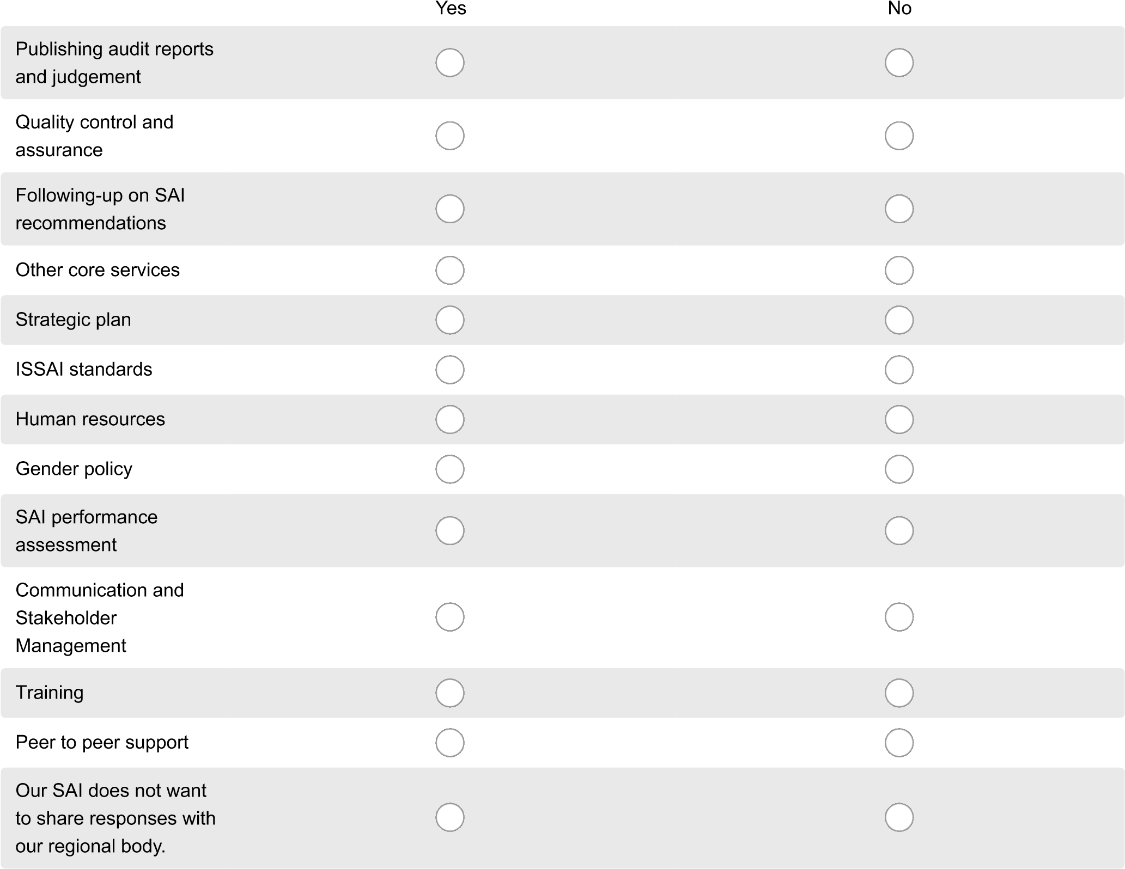
- If you consented to share your answers in the above selected areas with your regional body, what is your primary regional body?
AFROSAI: AFROSAI-E
AFROSAI: CREFIAF
ARABOSAI
ASOSAI
CAROSAI
EUROSAI
OLACEFS
PASAI
INTOSAI Global Survey 2017 - SAIs
26. Question about sharing data

- Does your SAI allow the IDI to share your answers to the question on donor coordination with the INTOSAI-Donor Cooperation? These questions are:
Select "Yes" to share a response and "No" if you do not want us to share your response.
Yes No
Is there an established
donor coordination
group to facilitate
coordination of capacity
development support to
your SAI, in which all
providers of support
participate?
What are the main
factors affecting the
success/failure of
coordination of support
provided to your SAI?
- Does your SAI allows the IDI to share your answers to the question on strategic plan with the INTOSAI Governing Board? These questions are refer to whether your SAI strategic and operational/annual plans and follow up questions:

Yes
No
Is the strategic plan
based on a holistic
needs assessment of
the SAI?
Is your strategic and
operational plans made
available to the public?
What mechanisms does
your SAI have in place in
this audit year for
monitoring and
evaluating the strategic
and operational plans?
INTOSAI Global Survey 2017 - SAIs
27. Your inputs to the survey
- If you wish to provide inputs to this survey or any other issues related to the subjects addressed in the survey, please use this space to do so.

Thank you very much for your time and inputs!

